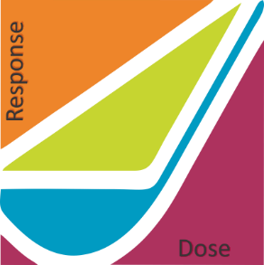American Nuclear Society - Health Physics Society

Applicability of Radiation - Response Models

to Low Dose Protection Standards:

Program Committee Meeting

Friday March 9, 2018

Alan Waltar, Wayne Glines, Tony Brooks, Steve Baker, Wanda Munn met in Steve’s office to discuss development of a conference technical program. The meeting was a follow up to the full planning committee on March 8.

In appreciation for the contribution that Mike Leimon in making to the conference and understanding his status as at young professional with limited financial resources, Mike will be granted free registration to the conference and free participation in the B Reactor tour and conference for himself and his wife.

Steve mentioned that he had a conversation with Darrell Fisher in which Darrell gave his perspective on how the conference should proceed. Steve’s perception is that while Darrell disagrees with some of the conference strategy, he seems willing to accept it.

Steve said the he had invited Jim Conca to the meeting, but Jim couldn’t make it. Jim has invited Mike Shellenberger to make a presentation at the conference but hadn’t provided details about the conference or what we would like Mike to cover. Steve will send an email to Jim making suggestions (done).

Steve had added Nolan Hertel, incoming Health Physics Society President, to the letterhead as Technical Program Co-Chair with Tony.

How to include the DOE presentations of epidemiological data and analysis of potential human health impacts associated with Russian nuclear activities proposed by Barrett Fountos is still being resolved. Barrett Fountos phone number 301-903-6740.

Solicitation of input from Christopher Clement, ICRP Scientific Secretary was not discussed.

Next meeting to be determined. Wayne will be on the other side of the mountains. Perhaps Tony and I can meet Friday with Wayne on the phone.